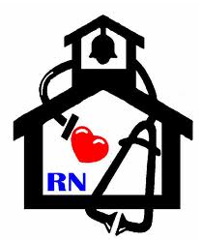
Nurse’s Nook
Pearl Lower Elementary – February
Aly Weems, School Nurse
Tobacco Effects on the Heart 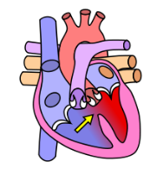
Smoking affects the body in many ways. The heart is extremely vulnerable to smoking. Smokers are at risk for several heart diseases, heart attack, and stroke.
Smoking and your heart
- Smoking causes atherosclerosis- In this condition the lining of the artery deteriorates and fat deposits and plaque block the blood flow through the arteries. In coronary artery disease, the arteries that supply blood become narrow and restrict the flow of oxygen laden blood to the heart, especially when there is increased activity. The extra pressure on the heart in pumping the blood causes chest pain.
- A smoker is at risk of heart attack. The more cigarettes he or she smokes, the chance of suffering from a heart attack are high.
- Increased risk of stroke.
- Blood clotting can occur.
- Passive smokers exposed to the smoke are also at a risk of a heart attack and cardio vascular disease. Even though, they do not smoke, they inhale the smoke.
- Increase in number of deaths due to heart diseases.
- Increase in cholesterol as well as carbon monoxide levels, which are bad for the heart.
- Tobacco smoke can increase the count of white blood cells, which is a risk factor for heart diseases.
- Nicotine can trigger off palpitations.
- Smokers can develop abdominal aortic aneurysms.
- Decreased supply of oxygen to the heart.
- Smoking raises blood pressure.
- Cigarette smoking affects circulation.
- If you or a loved one needs help quitting, you can call 1-800-QUITNOW or 1-800-784-8699! It’s never too late to quit!

